SEMINAR REPORT
In vitro plant secondary metabolite production: A hotspot for pharmaceutical phytochemicals
By
Abhaya M. C.
(2018-12-004)

Presented on 21-11-2019
Submitted in partial fulfilment of requirement of the course
PSMA 591: Master’s Seminar (0+1)

DEPARTMENT OF PLANTATION CROPS AND SPICES
COLLEGE OF HORTICULTURE
KERALA AGRICULTURAL UNIVERSITY
VELLANIKKARA, THRISSUR, KERALA- 680656

2020
DECLARATION

I, Abhaya M. C. (2018-12-004) declare that the seminar entitled “In vitro plant secondary metabolite production: A hotspot for pharmaceutical phytochemicals” has been prepared by me, after going through various references cited at the end and has not been copied from any of my fellow students.

Vellanikkara Abhaya M. C.
25/01/2020 2018-12-004

CERTIFICATE

This is to certify that the seminar report entitled “In vitro plant secondary metabolite production: A hotspot for pharmaceutical phytochemicals” has been solely prepared by Abhaya M. C. (2018-12-004), under my guidance and has not been copied from seminar reports of any seniors, juniors or fellow students.

Vellanikkara Dr. B. Suma
25/01/2020 Professor and Head
Cocoa Research Centre
Vellanikkara

CERTIFICATE

This is to certify that the seminar report entitled “In vitro plant secondary metabolite production: A hotspot for pharmaceutical phytochemicals” is a record of seminar presented by Abhaya M. C. (2018-12-004) on 21st November, 2019 and is submitted for the partial requirement of the course PSMA 591.

Dr. Anil Kuruvila
Professor
Department of Agricultural Economics
College of Horticulture, Vellanikkara

Dr. Sangeeta Kutty M.
Assistant Professor
Department of Vegetable Science
College of Horticulture, Vellanikkara

Dr. Reshmy Vijayaraghavan
Assistant Professor
Department of Plant Pathology
College of Horticulture, Vellanikkara

INDEX
Sl. No. | Title | Page No.
1 | Introduction | 10
2 | Principle | 11
3 | Major Advantages of in vitro secondary metabolites production | 11
4 | Procedure for in vitro secondary metabolites production | 11
5 | Standardization of culture methods  5.1 Cell suspension culture  5.2 Organ culture  5.3 Adventitious Shoot cultures  5.4 Adventitious Root culture  5.5 Hairy root culture | 12-20  12-14  14-15  15  15-16  16-20
6 | Strategies to improve secondary metabolites production  6.1 Selection of high-producing strains  6.2 Culture media optimization  6.2.1 Nutrient medium and salt strength  6.2.2 Carbon source and concentration  6.2.3 Nitrogen source  6.2.4 Phosphate levels  6.2.5 Growth regulator levels  6.2.6 Inoculum size/density  6.3 Optimization of Culture Environment  6.31 Temperature  6.32 Light Intensity and Quality  6.33 Hydrogen Ion Concentration  6.34 Agitation and Aeration  6.4 Elicitation  6.41 Biotic elicitors  6.42 Abiotic elicitors  6.5 Precursor feeding  6.6 Permeabilization  6.7 Immobilization  6.8 Scale-Up using bioreactors | 20-33  20  21- 24  21  22  23  23  23-24  24  25-27  25  26  26-27  27  27-29  28  28  29-30  31  31-33  33
7 | Flow chart of general strategies followed for production of secondary metabolites from plant | 34
8 | Limitations of in vitro secondary metabolites production | 34-35
9 | Conclusion | 35
10 | Discussion | 35-36
11 | References | 37-41
12 | Abstract | 42-43

LIST OF TABLES
SI. No. | Title | Page No.
1 | Important plant derived high value pharmaceuticals | 10 – 11
2 | Examples for secondary metabolites produced through cell suspension cultures | 14
3 | Examples for secondary metabolites produced through hairy root culture | 19 – 20
4 | Gymnema sylvestre cell suspension culture: effect of different carbohydrate sources | 22
5 | Panax ginseng cell suspension culture: effect of auxins on ginsenoside production | 24
6 | Panax ginseng hairy root culture: effect of incubation temperature | 25
7 | Classification of elicitors based on nature of origin | 28
8 | Examples for elicitors used for the production of secondary metabolites | 29
9 | Rauvolfia tetraphylla L. cell suspension culture: effect of tryptophan treatment | 30
10 | Precursor for different medicinal plants | 30
11 | Examples of immobilized plant cell systems used for production of secondary metabolites | 32 – 33
12 | Examples of bioreactor types used for plant cell cultures | 33

LIST OF FIGERS
SI. No | Title | Page No.
1 | Procedure for pharmaceutical phytochemical production | 11
2 | Procedure for cell suspension culture | 12
3 | Procedure for the production of secondary metabolites from organ culture | 14
4 | Mechanism of hairy root induction in plants | 17
5 | Gymnema sylvestre cell suspension culture: effect of medium strength | 21
6 | Gymnema sylvestre cell suspension culture: effect of carbohydrate concentration | 23
7 | Gymnema sylvestre cell suspension culture: effect of inoculum density | 25
8 | Panax ginseng hairy root culture: effect of light quality | 26
9 | Withania somnifera hairy root culture: effect of pH | 27
10 | Effect of methyl jasmonate elicitation on Panax ginseng cell suspension culture | 29
11 | Effect of permeabilizing agent dimethyl sulphoxide (DMSO) treatment in Catharanthus roseus cell suspension culture | 31
12 | Effect of alginate immobilization on ajmalicine production in the Catharanthus roseus cell suspension culture | 32

LIST OF PLATES
SI. No. | Title | Page No.
1 | Cell suspension culture | 13
2 | Procedure for the production of secondary metabolites from cell suspension culture | 13
3 | Adventitious shoot culture of Withania somnifera for Withanolide A production | 16
4 | Adventitious root culture of Panax ginseng | 16
5 | Natural genetic engineer: Agrobacterium rhizogenes | 17
6 | Hairy roots disease | 17
7 | Hairy root culture | 17
8 | Transfers of DNA segment (T - DNA) from Agrobacterium rhizogens large root-inducing (Ri) plasmid into the genome of the infected plant | 18
9 | Procedure of in vitro hairy root induction and secondary metabolites production | 18
10 | Hairy root cultures of Solanum trilobatum | 19
11 | Different types of bioreactors a. balloon type airlift bioreactors b. drum type airlift bioreactor | 33

In vitro plant secondary metabolite production: A hotspot for pharmaceutical phytochemicals
1. Introduction
Pharmaceutical phytochemicals are the biologically active compounds produced by the plants, which are used for the medicinal drug preparations. Plants have been the source for many chemical entities and bioactive molecules through the process known as metabolism. Plant cell carries out both primary and secondary metabolism. Primary metabolism involves synthesis of polysaccharides, proteins, lipids, RNA and DNA whereas secondary metabolisms activated only during particular stages of growth and development or during periods of stress. Plant kingdom synthesizes the enormous form of complex structured secondary metabolites to interact with the biotic environment and for the establishment of defence mechanisms.
In conventional methods, these high-value pharmaceutical phytochemicals are isolated either from the cultivated plants or from the wild plants to produce pharmaceutical drugs. However supply from the natural sources alone can’t meet the rising demand for clinical uses of phytochemicals, due to limitations such as low yield, requirement of a large area for cultivation, long pre harvesting period, influence of geographical and environmental variation in the secondary metabolites production and extinction of the plant species due to overexploitation. Chemical synthesis of these high-value medicinal compounds is also not economical, due to its complex structures.
For example the anti-cancer drug Taxol® (a registered trademark of Bristol-Myers Squibb) is a very important example of a potential pharmaceutical phytochemical. Taxol® was originally isolated from the bark of the Pacific Yew tree, Taxus brevifolia. This slow growing tree is principally found in the Pacific North-West. To obtain 1 kg of Taxol® requires the bark of more than 1000 trees, each up to 100 years old. An alternative approach to production is essential if Taxol® supplies are to be assured and if the Pacific Yew population is not to be destroyed (Kieran et al., 1997).
To overcome such problems, a new way i.e. the cell and organ culture, is emerging as an attractive alternative method. Advances in biotechnology particularly methods for culturing plant cell, provided a new means for the commercial production of even rare plants and the chemicals they provide.
Product | Use | Plant species
Ajmalicine | Antihypertensive | Catharanthus roseus
Artemisinin | Antimalarial | Artemisia annua
Berberine | Intestinal ailment | Coptis japonica
Campotothecin | Antitumour | Camptotheca acuminate
Codeine | Sedative | Papaver somniferum
Colchicine | Antitumour | Colchium autumnale
Digoxin | Heart stimulant | Digitalis lanata
Diosgenin | Steroidal precursor | Dioscorea deltoidea
Forskolin | Bronchial asthma | Coleus forskolii
Ginsenosides | Health tonic | Panax ginseng
Morphine | Sedative | Papaver somniferum
Podophyllotoxin | Antitumour | Podophyllum petalum
Quinine | Antimalarial | Cinchona ledgeriana
Sanguinarine | Antiplaque | Sanguinaria canadensis
Shikonin | Antibacterial | Lithospermum erythrorhizon
Taxol | Anticancer | Taxus brevifolia
Vincristine | Antileukemic | Catharanthus roseus
Vinblastine | Antileukemic | Catharanthus roseus

Table 1. Important plant derived high value pharmaceuticals (Ravishankar and Rao, 2000)
2. Principle
The principle of this biotechnological tool is the biosynthetically totipotent nature of the culturing cells. Cell preserves the genetic information and thus it is capable of producing a large number of the biochemical which are found in the parent, under a suitable nutrient culture medium (Yue et al., 2014).
3. Major Advantages of in vitro secondary metabolites production
- Phytochemicals can be produced under controlled conditions as per market demands.
- Culture systems are independent of environmental factors, seasonal variations and geographical constraints that affect secondary metabolites production in the nature.
- Cell growth can be controlled to facilitate improved product formation.
- The quality of the product will be consistent as it is produced by a specific cell line.
- Recovery of the product will be easy.
- Plant cultures are particularly useful in case of plants which are difficult or expensive to be grown in the fields.
- Mutant cell lines can be developed for the production of novel compounds of commercial importance, which are not normally found in plants.
- The production time is less and labour costs are minimal.
4. Procedure for pharmaceutical phytochemical production

Standardization of culture methods
Optimization of scale up methods
Adoption of strategies to improve secondary metabolites production

Fig 1. Procedure for pharmaceutical phytochemical production

5. Standardization of culture methods
Cell suspension culture and organ cultures like adventitious root, adventitious shoot and Agrobacterium rhizogenes mediated hairy root culture are the main approaches, used in the production of high value pharmaceutical phytochemicals.
5.1 Cell suspension culture
Cell suspension culture is a type of culture in which single cells or small aggregates of cells multiply while suspended in agitated liquid medium. Callus proliferates as an unorganised mass of cells. To achieve an ideal cell suspension, most commonly a friable callus is transferred to agitated liquid medium where it breaks up and readily disperses. After eliminating the large callus pieces, only single cells and small cell aggregates are again transferred to fresh medium and after two or three weeks a suspension of actively growing cells are produced.

Procedure for cell suspension culture
Select plant organ/tissues
Rinse and sterilize the explants
Cut and place the explants on a solid medium
2–6 weeks
Callus cultures
Chop/cut the callus and put in a liquid medium
1–2 weeks
Cell suspension culture
Separate fine cells from aggregates by
Filtering (15 min) or Decantation/ pipetting (5 min) or Addition of pectinase (2 min)
Fine cell suspension culture
Large scale

Fig 2. Procedure for the cell suspension culture

(Mustafa et al., 2011)
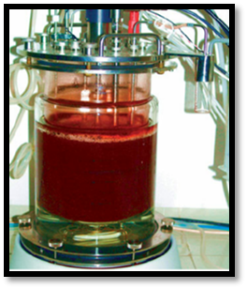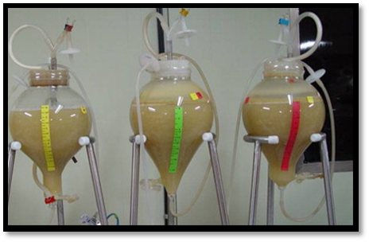
Plate 1. Cell suspension culture

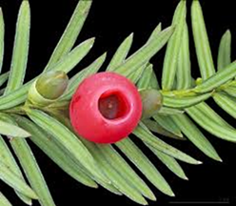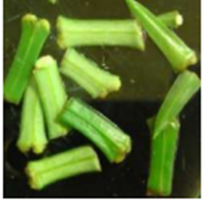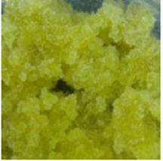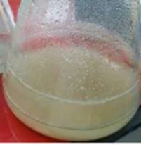
Explant selection
Primary callus suspension culture
Primary callus production in solid medium
Plant selection

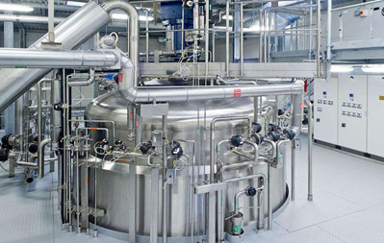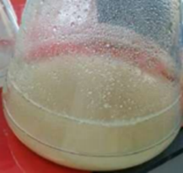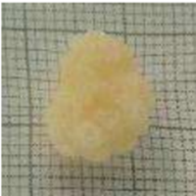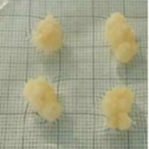
Aggregates from single cell
Selection of high producing strain
Selected strain cell suspension culture
Scale up using bioreactors

Plate 2. Procedure for the production of secondary metabolites from cell suspension culture
Taxus cell suspension culture produced by Wang et al. (2001) for production of taxol, a well-known anticancerous drug. Calli were first produced from the young stems of a Taxus tree using the MS basal medium supplemented with 0.1 mg/l 2,4-dichlorophenoxyacetic acid (2,4-D), 0.5 mg/l R- Naphthelene acetic acid (NAA), 0.5 mg/l benzyl adenine (BA), 30 g/l sucrose, and 8 g/l agar. Suspension culture was initiated from a ninth generation callus and cultured in a liquid medium similar to that for callus culture but excluding the 2,4-D and agar.
Ginsenosides, a group of saponins which are known for its antioxidant, cardioprotective, immunomodulatory activities produced successfully from cell suspension culture of Panax ginseng in airlift bioreactor (Thanh et al., 2014).
Catharanthus roseus cell suspension culture was established from leaf explant of the Egyptian cultivar on B5 medium. The medium contained B5 salts, myo-inositol 100 mg/l, thiamine 10 mg/l, pyridoxine 1 mg/l, nicotinic acid 1 mg/l, naphthalene acetic acid 1.86 mg /l and sucrose 20 g/l. Cell suspension produced by using same medium without agar (El-Sayed et al., 2004).
Plant | Secondary metabolites | Reference
Cassia acutifolia | Anthraquinones | Nazif et al., 2000
Catharanthus roseus | Indole alkaloids | Moreno et al., 1993
Coscinium fenestratum | Berberine | Narasimhan and Nair, 2004
Dioscorea deltoidea | Diosgenin | Heble and Staba, 1980

Table 2. Examples for secondary metabolites produced through cell suspension cultures
5.2 Organ culture

A certain degree of differentiation may be needed for the biosynthesis of secondary metabolites, when the target metabolite is only produced in specialized plant tissues or glands. Then use of differentiated organ cultures is required.
Indirect organogenesis
Callus cell line
Plant

Direct organogenesis

Infection with
Agrobacterium tumefaciens
Agrobacterium rhizogenes

Screening for genetically stable lines
(Stable metabolite production)

Shoot teratoma lines (Medium free of hormones)
Hairy root lines (Medium free of hormones)

Untransformed shoot or roots

Bioreactor scale up

Fig 3. Procedure for the production of secondary metabolites from organ culture

In tissue culture formation of organs is known as organogenesis. It is mainly divided in to two.
1. Indirect Organogenesis
Formation of organs directly through the callus is called indirect organogenesis
2. Direct Organogenesis
The production of direct buds or shoots from a tissue with no intervening callus stage is called direct organogenesis.
Organ culture such as adventitious root culture, shoot culture and agrobacterium mediated hairy root culture are mainly used in the secondary metabolites production.

5.3 Adventitious Shoot cultures
It is possible to cultivate plant aerial parts (shoots) for the production of secondary metabolites. Shoot cultures can be transgenic, the so-called shooty teratomas, if they are obtained after infection with Agrobacterium tumefaciens, or non-transgenic through the simple use of appropriate hormonal balance. Shoot cultures have genetic stability and good capacities for secondary metabolite production (Bourgaud et al., 2001).
Shoot cultures have been established in many medicinal plants which can accumulate secondary metabolites higher than that of natural plants. For example, shoot cultures were established in Bacopa monnieri for the production of bacoside A and regenerated shoots possessed three fold higher bacoside A than field grown plants (Praveen et al., 2009). Similarly, the shoots of Nothapodytes nimmoniana which were regenerated in the semisolid and liquid medium had several fold higher camptothecin compared to the mother plants (Dandin and murthy, 2012).
In nature withanolide A is obtained from the roots of the Withania somnifera. Sangwan et al. (2007) reported that withanolide A can be produced from the in vitro shoot cultures of Withania somnifera. Nodel segments used as explants and MS medium supplemented with 1 ppm BAP and 0.5 ppm kinetin used as medium.
5.4 Adventitious Root culture
Adventitious roots also stand for a good source of secondary metabolites. Adventitious roots induced by in vitro methods showed high rate of proliferation and active secondary metabolism. Adventitious roots are natural, grow vigorously in phytohormone supplemented medium and have shown tremendous potentialities of accumulation of valuable secondary metabolites.
Panax ginseng adventitious roots were induced from the root explants of 100 years old mountain ginseng on Murashige and Skoog medium, supplemented with growth regulators. The root segments developed calli on MS medium supplemented with 4.53 μM 2, 4-dichlorophenoxy acetic acid (2,4-D), 0.46 μM kinetin, and 3 % sucrose (Murthy et al., 2014).
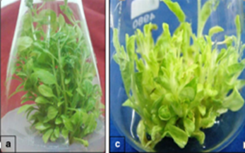

Plate 3. Adventitious shoot culture of Withania somnifera for withanolide A production

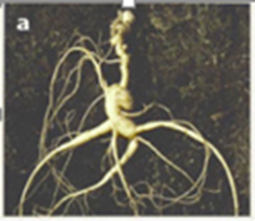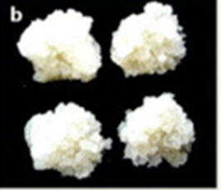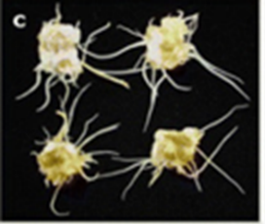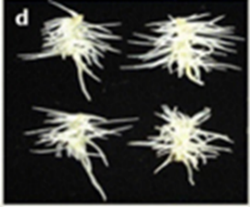
Callus formation
Adventitious root formation
Root explant

Plate 4. Adventitious root culture of Panax ginseng

5.5 Hairy root culture
Hairy root disease is caused by the infection of wounded higher plants with Agrobacterium rhizogenes. This gram negative soil bacterium transfers a DNA segment (T-DNA) from its large root-inducing (Ri) plasmid into the genome of the infected plant. This T-DNA carries a set of genes that encode enzymes which control auxin and cytokinin biosynthesis. The new hormonal balance induces the formation of proliferating roots, called hairy roots, that emerge at the wounding site. The hairy root phenotype is characterized by fast hormone-independent growth, lack of geotropism, lateral branching and genetic stability. (Guillon et al., 2016)
Owing to their stable and high productivity, hairy root cultures have been investigated for several decades for potential to produce the valuable metabolites under in in vitro condition. The greatest advantage of hairy roots is that they often exhibit about the same or greater biosynthetic capacity for secondary metabolite production as compared to their parent plants. Even in cases where a particular secondary metabolite accumulates only in the aerial part of an intact plant, hairy root cultures have been probably shown to accumulate the same metabolite. (Zhou et al., 2011)

Wounded plant cells
(Recognition by Agrobacterium)
Signal molecules
(Auxin and cytokinin biosynthesis)
Attachment of Agrobacterium with plant cells

Transfers a DNA segment (T - DNA) from its large root-inducing (Ri) plasmid into the genome of the infected plant

Hairy root induction

Fig 4. Mechanism of hairy root induction in plants

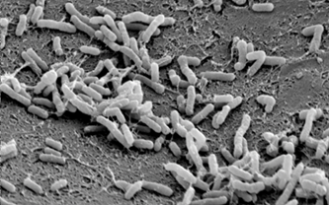

Plate 5. Natural genetic engineer: Agrobacterium rhizogenes
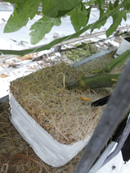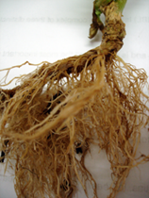
Plate 6. Hairy root disease

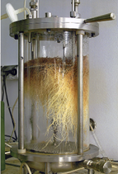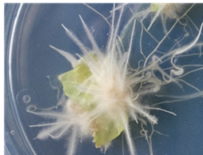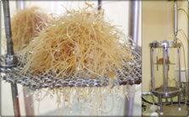

Plate 7. Hairy root culture

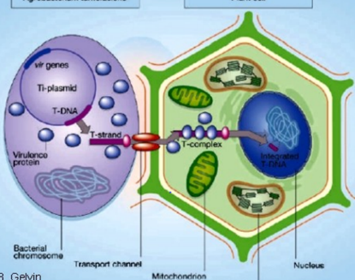

Plate 8. Transfers of DNA segment (T - DNA) from Agrobacterium rhizogens large root-inducing (Ri) plasmid into the genome of the infected plant

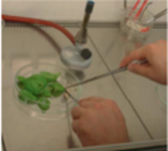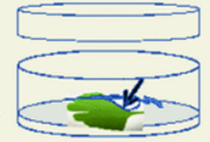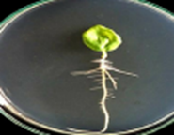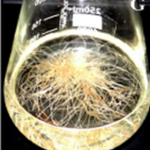
Scale up
Sub-culturing
Induction of neoplastic roots at infection sites
Explant inoculation with Agrobacterium strain
Making wounds in explant

Plate 9. Procedure of in vitro hairy root induction and secondary metabolites production
Shilpa et al. (2015) established hairy root cultures of Solanum trilobatum L. from leaf explants infected with Agrobacterium rhizogenes strains viz., MTCC 532, MTCC 2364 and ATCC A4. It is reported that small exogenous auxin concentrations usually increase both elongation rate and lateral branching of hairy roots.
Most authors working on hairy root cultures have reported the long-term genetic stability of this material. A major characteristic of hairy roots is that they are able to produce secondary metabolites continuously with growth. Hence it is possible to get a continuous source of secondary compounds from actively growing hairy roots.

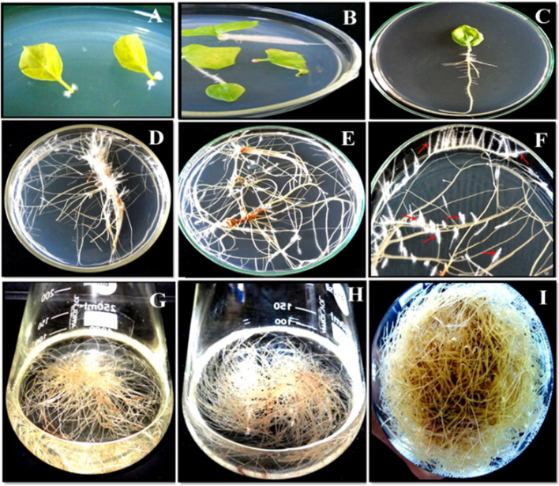
Plate 10. Hairy root cultures of Solanum trilobatum

Plant | Secondary metabolites | Biological activity | Reference
Centella asiatica | Asiaticoside | Anti-inflammatory | Kim et al., 2007
Artemisia annua | Artemisinin | Anti-malaria | Putalun et al., 2007
Ophiorrhiza pumila | Camptothecin | Anti-cancer drugs | Sirikantaramas et al., 2007
Plumbago indica | Plumbagin | Anti-microbial | Gangopadhydy et al., 2008
Papaver bracteatum | Benzylisoquinoline | Anti-tumorogenic, anti-inflammatory, muscle relaxant. | Rostampour et al., 2009
Taxus x media var. Hicksii | Taxane | Anti-cancerous, such as ovary, breast, head and neck, bladder  and cervix, melanomas, lung cancers | Syklowska-Baranek  et al., 2009
Panax quinquefolium | Ginsenosides | Immuno-modulatory, adaptogenic, anti-ageing | Mathur et al., 2010
Brugmansia candida | Scopolamine,  anisodamine,  hyoscyamine | Anti-cholinergic activity | Cardillo et al., 2010
Hyoscyamus albus | Sesquiterpene-type  phytoalexins | Anti-microbial | Kawauchi et al., 2010

Table 3. Examples for secondary metabolites produced through hairy root culture

6. Strategies to improve secondary metabolites production
Different systematic strategies like selection of cell lines and clones, optimization of medium and culture environments, elicitor treatment, precursor feeding, permeabilization, immobilization, metabolic engineering and scale-up using bioreactors can boost the commercial success of culture system.
6.1 Selection of high-producing strains
The most important step for higher production of secondary metabolites is the screening of highly productive cell line. It is based on the theory of biochemical heterogeneity in plant cells. Plant cell cultures represent a heterogeneous population in which physiological characteristics of individual plant cells are different. Usually high yielding cell lines originate from high-producing plants, but the production levels of cells originating from high-producing plants also display variability. Variability leads to a reduction in metabolite productivity with sub-culturing. Plant cell suspension is composed of low-yielding, high-yielding and non-producing cells. Selecting high biomass and metabolites producing cell lines is of utmost importance in optimizing the productivity of in vitro cultivated plant cells, tissues and organs. (Yue et al., 2014)
Initiation of cell and organ cultures begins with the choice of a parent plant with high content of the desired product for callus or organ induction to obtain high yielding cell/organ lines. Secondary metabolite accumulation in plants is specific to its genotype. For example, the concentration of bacoside A (a triterpenoid saponin) varies among different genotypes ranging from 3.53 to 18.36 mg/g DW (Naik et al., 2012). Similarly, the amount of camptothecin (a quinoline alkaloid) varies among the different species (Camptotheca spp., Ervatamia spp., Ophiorrhiza spp., Nothapodytes spp.) and even in different organs of the plant (0.03–0.4 % DW) (Ramesha et al., 2008). It indicates that selection of suitable genotype and a suitable organ is essential for higher secondary metabolites production.
High yielding cell lines are identified by visual screening, studying growth kinetics and metabolite profiling using various qualitative and quantitative analytical instrumentation techniques. Techniques such as HPLC (High Performance Liquid Chromatography) and RIA (Radioimmunoassay) were used to screen for high-yielding cell lines. Cell cloning methods are supposed as a credible way of selecting high-yielding cell lines from the suspension culture, which is similar to the monocolony isolation of bacteria. Mutation strategies and the use of selective agents have also been employed in order to obtain overproducing cell lines (Yue et al., 2014)

6.2 Culture media optimization
Media optimization is known to be the most fundamental approach in plant cell culture technology. Cultural conditions optimization is achieved in order to improve growth rates of cells and higher yield of desirable products. Culture environment manipulation of certain constituents (e.g., nutrient levels, stress factors, light, and growth regulators) is the effective means to increase product accumulation. This manipulation often influences the expression of many secondary metabolite pathways. Some constituents of plant cell culture media significantly determine the growth and accumulation of secondary metabolites (Yue et al., 2014).
Some of the key factors are choice of culture medium, nutrient medium and salt strength, carbon source and concentration, nitrogen source, phosphate levels, growth regulator levels and inoculum size/density.

6.2.1 Nutrient Medium and Salt Strength

Various types of media formulations were tested and utilized earlier for the establishment of cell and organ suspension cultures for the production of secondary metabolites. Murashige and Skoog (MS), Gamborg’s (B5), Schenk and Hildebrandt (SH), Linsmaier and Skoog (LS) media are widely used. The appropriate concentration of medium constituents (salt strength) is crucial for the growth of isolated cells and organs.
The full strength MS medium was suitable for both biomass and gymnemic acid accumulation in cell suspension cultures of Gymnema sylvestre (Nagella and Murthy, 2011).

Fig 5. Gymnema sylvestre cell suspension culture: effect of medium strength
Among the 0.25, 0.5, 0.75, 1.0, 1.5 and 2.0 strength MS medium tested, full strength (1.0) medium was found better for biomass accumulation and withanolide A production in Withania somnifera cell suspension cultures (Praveen and Murthy, 2010). Interestingly, some medium salts like calcium chloride and sodium chloride could be working as signal inducers to stimulate secondary metabolism.
In ginseng adventitious root cultures, maximum biomass and growth rate were obtained in 0.75 strength MS medium and ginsenoside content and yield were higher in 0.5 salt strength MS medium (Murthy et al., 2017).

6.2.2 Carbon Source and Concentration

Plant cell cultures behave heterotrophically under in vitro conditions and thus essentially require sugar supplementation as carbon inorganic source. It has been found that the amount of sucrose affects the accumulation of secondary metabolite in various cultures. Osmotic stress created by sucrose alone and with other osmotic agents also affects secondary metabolite production. It was also noticed that sucrose has a dual function (carbon source and osmotic agent). Plant cell cultures are usually grown using simple sugars such as glucose, fructose, maltose, sucrose and their combinations as an energy and carbon source (Bhatia et al., 2015).
In Gymnema sylvestre cell culture the various sugars tested, sucrose was found to be an ideal carbohydrate source for the biomass accumulation (11.56 g/l DW) and the highest production of gymnemic acid content (9.95 mg/g DW). Similarly, concentration of carbohydrate supplemented to the medium greatly affects the biomass and metabolite production. For example, of the various levels of sucrose (1–8 % w/v) tested in Gymnema sylvestre cell cultures, 3 % sucrose in the medium favoured the accumulation of biomass, whereas the highest amount of gymnemic acid (10.1 mg/g DW) was accumulated in the medium supplemented with 4 % sucrose (Nagella and Murthy, 2011).

Carbohydrate sources (3%) | Fresh weight (g/l) | DW (g/l) | Gymnemic acid content (mg/g DW)
Glucose | 118.00 | 10.66 | 8.56
Fructose | 100.91 | 9.23 | 6.58
Maltose | 86.507 | 7.68 | 6.99
Glucose : fructose (1:1) | 100.90 | 9.07 | 8.72
Fructose : sucrose (1:1) | 94.25 | 8.36 | 9.26
Sucrose : glucose (1:1) | 117.22 | 10.66 | 9.24

Table 4. Gymnema sylvestre cell suspension culture: effect of different carbohydrate sources

Fig 6. Gymnema sylvestre cell suspension culture: effect of carbohydrate concentration

6.2.3 Nitrogen Source

In cell suspension cultures, nitrogen supplementation chiefly influences the level of protein or amino acid products. Certain media, e.g., MS, LS, or B5, are known to be the rich sources of nitrogen as they contain relatively high amounts of nitrate and ammonium salts. Production of secondary metabolite is highly influenced by the ratio of ammonium/nitrate–nitrogen and overall levels of total nitrogen (Bhatia et al., 2015).
In the shoot cultures of Bacopa monnieri, the effect of macro elements was tested by varying the levels of NH₄NO₃, KNO₃, CaCl₂, MgSO₄ and KH₂PO₄ in the MS medium each at 0.05, 1.0, 1.5 and 2.0 strengths and optimum number of shoots (99.33/ shoots explants), biomass (0.150 g DW) and the highest production of bacoside A (17.9 mg/g DW) were obtained with 2x strength NH₄NO₃ ( Naik et al., 2011).

6.2.4. Phosphate Levels
In addition to sugar and nitrogen, phosphate levels also markedly affect the production of secondary metabolites in plant cell cultures. It has been studied that the higher concentration of phosphate enhances cell growth and negatively influences secondary metabolism. Various examples reported that decreasing phosphate concentration in medium stimulates or induces both the product and its associated enzymes that are responsible for its production. (Bhatia et al., 2015)
6.2.5 Growth Regulator Levels
Growth regulators affect the growth and metabolite accumulation significantly because cell, adventitious root or shoot cultures generally need exogenous supply of growth regulators for growth, proliferation of biomass and metabolite accumulation. Whereas, hairy root cultures are genetically transformed roots which are produced by using Agrobacterium rhizogenes and they have the ability to grow without the addition of plant growth regulators. There are various critical reports available on the effects of growth regulators on secondary product accumulation. Synthesis and accumulation of secondary metabolites in various cultured plant cells are markedly affected by the type and concentration of auxin or cytokinin or the auxin/cytokinin ratio. It has been studied in various reports that 2,4-D restricts the accumulation of secondary metabolite (Bhatia et al., 2015).
Thanah et al. (2014) reported that NAA 3mg/l is ideal for maximum ginsenoside production in Panax ginseng cell suspension culture. He also reported that 2,4- D is the least favouring auxin for secondary metabolites production.

Auxin | Concentration (mg/l) | Ginsenosides (mg/g DW)
2,4 D | 1 | 4.16 ± 0.3
IBA | 1 | 5.21 ± 0.3
 | 3 | 5.58 ± 0.3
 | 5 | 5.74 ± 0.2
 | 7 | 7.29 ± 0.2
 | 9 | 5.64 ± 0.3
NAA | 1 | 7.18 ± 0.2
 | 3 | 8.76 ± 0.1
 | 5 | 7.44 ± 0.1
 | 7 | 6.24 ± 0.3
 | 9 | 4.61 ± 0.3

Table 5. Panax ginseng cell suspension culture: effect of auxins on ginsenosides production

6.2.6 Inoculum Size/Density

Inoculum size/density is an important factor for plant cell and organ suspension cultures, which can influence the growth, biomass accumulation and metabolite formation. There is a critical minimum inoculum size below which cell interestingly promote not only the cell growth but also the secondary metabolite biosynthesis. (Bhatia et al., 2015)
There are many reports on the influence of inoculum size/density of the cultured cells on biomass and metabolite accumulation. In cell suspension cultures of Gymnema sylvestre, the various quantities of inoculums (2.5, 5.0, 10.0 and 20.0 g/L) were tested, optimum density of biomass (11.25 g /l) as well as gymnemic acid (9.95 mg g −1 DW) was achieved with 10.0 g/l inoculum. A higher (20.0 g/l) and lower (2.5 g/ l) inoculum was not suitable for biomass and gymnemic acid accumulation (Nagella and Murthy, 2011).

Fig 7. Gymnema sylvestre cell suspension culture: effect of inoculum density
6.3 Optimization of Culture Environment
In addition to media components culture environmental conditions such as pH, oxygen, light, humidity, temperature, type, and nature of medium have significant effects on secondary metabolite accumulation in several cultures.
6.3.1 Temperature
Since the early development of plant biotechnology, temperature effect has been investigated in cell and organ cultures and a temperature range of 17–25°C is normally used for the maintenance of cultured cells and organs. However, each plant species may show better growth and metabolism under different temperature regimes.
Yu et al. (2005) studied the growth of hairy roots of ginseng under differential temperatures such as 13/20, 20/13, 25/25, and 30 °C/25 °C for 16/8 day and night cycles; got highest hairy root biomass with the cultures incubated at 20°C/13°C. However, total ginsenosides was optimum (10.5 mg/g DW) with the cultures incubated at 25°C/25°C and ginsenoside production was also highest (133.4 mg/l) at this temperature.
Temperature  (⁰C)  Day and night cycle | Biomass |  | Ginsenoside  (mg/g DW)
 | FW (g) | DW (g)
13/20 | 431 ± 1.0 | 28 ± 1.0 | 4.5 ± 0.1
20/13 | 892 ± 0.9 | 65 ± 0.8 | 8.2 ± 0.1
25/25 | 889 ± 0.6 | 51 ± 0.7 | 10.5 ± 0.1
30/25 | 764 ± 0.8 | 64 ± 0.9 | 6.4 ± 0.1

Table 6. Panax ginseng hairy roots culture: effect of incubation temperature.

6.3.2 Light Intensity and Quality
Light may be used as an energy source or just as an elicitor which affects the growth and accumulation of secondary metabolites in cultured cells and organs. Yu et al., (2005) have studied the effect of fluorescent light, metal halide light, blue light, red light and blue plus red light on biomass growth and synthesis of ginsenosides in ginseng hairy root cultures and reported that hairy root growth was stimulated by red light than dark. Fluorescent irradiation enhanced the accumulation of ginsenosides (5.3 mg/g DW). They also noticed differential accumulation of Rb and Rg group of ginsenosides in dark grown and light grown cultures, Rb group ginsenosides were highest in the cultures grown in dark (4.5 mg/g DW ) and Rg group of ginsenosides were optimal in the cultures grown in light (5.3 mg/g DW). These results suggest that manipulation of secondary metabolite accumulation is possible by manipulating light and dark regimes.

Fig 8. Panax ginseng hairy roots culture: effect of light quality

6.3.3 Influence of hydrogen Ion Concentration

The medium pH is usually adjusted between 5 and 6 before autoclaving and extremes of pH are avoided. The concentration of hydrogen ions in the medium changes during the course of culture due to nutrient uptake or due to the accumulation of metabolites in cultures. In Withania somnifera hairy root cultures, initial pH of the medium which was set at 5.8 was favourable for the accumulation of biomass (12. 1 g/l DW) and medium pH of 6.0 favoured the accumulation of withanolide A in the roots (13.84 mg/g DW) (Praveen and murthy, 2012).

Fig 9. Withania somnifera hairy root cultures: effect of pH

6.3.4 Agitation and Aeration

Parameters like aeration and agitation play a vital role in large-scale production of secondary metabolites. Thus, the design of bioreactor or microenvironment facilitating agitation and aeration considerably affects secondary metabolites production. Type and amount of gas perfuse in the culture environment and design of propeller for agitation regulate the production level (Bhatia et al., 2015).
Oxygen requirement of plant cells is comparatively lower than that of microbial cells due to their low respiratory rates. However, oxygen supply has been shown significantly affecting the secondary metabolite production in cell cultures. The effects of oxygen supply within the range of 20.8 %, 30, 40 and 50 % was studied by Thanh et al. (2014) with ginseng cell cultures and a 40 % oxygen supply was found to be beneficial for the production of both cell biomass and ginsenoside yield respectively.

6.4 Elicitation
Plant secondary metabolites are produced by plant cells in response to environmental perturbation during in vivo growth and as defensive strategy triggered against invading pathogen elicitors. Hence, there is increasing interest to use compounds that trigger the defense response by the cultivated plant cells, tissues or organs for an improved productivity of bioactive compounds in the in vitro cultures. An ‘elicitor’ may be defined as a substance which, when introduced in small concentrations to a living cell system, initiates or improves the biosynthesis of specific compounds. Elicitation is the induced or enhanced biosynthesis of metabolites due to addition of trace amounts of elicitors (Radman, 2003).
The agents could be biotic or abiotic and may include signaling molecules (e.g., methyl jasmonate, salicylic acid), microbial cell wall extracts (e.g., yeast extract, chitosan), inorganic salts, heavy metals or even physical agents such as UV radiation among others. This could provide an alternative avenue to improve production in the plant in vitro cultures (Namdeo, 2007).
6.4.1 Biotic elicitors
Biotic elicitors are substances with biological origin/ generated within living organisms, either from pathogens or by the plant itself, whose functions are coupled to the receptors and act by activating or inactivating a number of enzymes or ion channels. They include biotic elicitors from fungi, bacteria or herbivores, plant cell wall fragments as well as chemicals that are released at attack site by plants upon pathogen or herbivore attack (Namdeo, 2007).

6.4.2 Abiotic elicitors
Abiotic elicitation means triggering the synthesis of phytochemicals in plants by using chemical or physical stimuli. Abiotic elicitors are the substances of non–biological origin, mostly inorganic salts like Cu, Ca, Cd ions and physical factors like pH, heavy metals, salt stress, water stress, light, temperature, cold, heat etc (Namdeo, 2007).

Biotic elicitors | Abiotic elicitors
Directly released by microorganisms and  recognized by the plant cell (enzymes,  cell wall fragments) | Light and temperature
Formed by action of microorganisms on  plant cell wall (fragments of pectins etc.) | Heavy metals
Formed by the action of plant enzymes on  microbial cell walls (chitosan, glucans) | pH
Compounds, endogenous and constitutive in nature, formed or released by the plant cell  in response to various stimuli. | Salt stress

Table 7. Classification of elicitor based on nature of origin
There are reports that methyl jasmonate when used as an elicitor, increased taxol yield in the Taxus chinensis cell suspension culture (Wu and Lin, 2003) and ginsenoside yield in the Panax ginseng cell suspension cultures (Thanh et al., 2005)

Fig 10. Panax ginseng cell suspension culture: effect of methyl jasmonate elicitation

Sl. No. | Plant species | Product | Elicitor | Reference
1 | Catharanthus roseus | N-acetyl-tryptamine | Pythium aphanidermatum | Eilert et al.,1986
2 | Catharanthus roseus | Ajmalicine | Trichoderma viride | Namdeo et al., 2002
3 | Dioscorea deltoidea | Steroid (Diosgenin) | Fungal mycelia | Rokem et al., 1984
4 | Lithospermum erythrorhizon | Shikonin | Agaropectin | Fukui et al., 1983
5 | Atropa belladona | Tropane alkaloids | Cu 2+, Cd 2+ | Lee et al., 1998
6 | Catharanthus roseus | Indole alkaloids | Diethyl amino ethyl dichloro phenyl ether | Lee et al., 1998
7 | Coleus forskolin | Forskolin | Methyl jasmonate (MeJA) | Babu, 2000
8 | Panax ginseng | selenium | ginseng saponin | Jeong and Park,2006

Table 8. Examples for elicitors used for the production of secondary metabolites
6.5 Precursor feeding
Exogenous supply of a biosynthetic precursor to culture medium may also increase the yield of the desired product. This approach is useful when the precursors are inexpensive. The concept is based on the idea that any compound, which is an intermediate, in or at the beginning of a secondary metabolite biosynthetic route, stands a good chance of increasing the yield of the final product (Namdeo et al., 2007).
Attempts to induce or increase the production of plant secondary metabolites, by supplying precursor or intermediate compounds, have been effective in many cases. For instance tryptophan, in the callus induction medium of Rauvolfia tetraphylla L. enhances the yield of alkaloid, reserpine. Among various concentration tested 50 mg/l tryptophan was found to be optimum for maximum reserpine production. (Anitha and Ranjitha, 2006).

Treatment | Crude alkaloid content (mg/g DW) | Reserpine content  (mg/g DW)
Control | 5.0 | 0.9
25 mg/l trp | 6.2 | 1.7
50 mg/l trp | 7.1 | 2.1
100 mg/l trp | 3.1 | 0.3

Table 9. Rauvolfia tetraphylla L. cell suspension culture: effect of tryptophan (trp) treatment
Sl.  No. | Plant | Precursor | Product | Reference
1 | Atropa belladonna | Tropic acid, tropinone and tropanoltropic acid,  tropinone, tropanol | Tropane alkaloid | Simola, 1990
2 | Catharanthus roseus | Secologanin, loganin or loganic acid | Ajmalicine and strictosidine | Moreno, 1993
3 | Catharanthus roseus | Tryptophan | Ajmalicine | Namdeo, 2004
4 | Podophyllum  hexandrum | Phenylalanine, cinnamic acid and ferulic acid | Podphyllotoxin and 4 -  Dimethyl podophyllotoxin | Jackson and Dewick, 1984
5 | Taxus chinesis | Phenyalanine, Benzoyl glycine | Taxol | Srinivasan et al., 1996

Table 10. Precursors for different medicinal plants

6.6 Permeabilization

Plant secondary metabolites formed by plant cell cultures are usually stored in the vacuoles and it is, therefore, desirable to extract the products into the culture medium such that the purification procedure may become easier and continuous recovery and production of the product may be conducted. Removal of secondary metabolites from the vacuoles of the cells would also reduce the possible product inhibition thus increasing the productivity.
Many attempts have been made to permeabilize the plant cell membranes in a reversible manner with organic solvents. Organic solvents such as isopropanol, dimethylsulfoxide (DMSO) and polysaccharides like chitosan have been used as permeabilizing agent. However, when various chemicals are used as pemeabilizing agents they affect the cell viability. Therefore, selection of chemical agent with due consideration to its effect on cell growth may lead to substantial release of secondary metabolites. Other permeabilization methods such as electric field stress and ultrasound methods have also been used for recovery of secondary metabolites.
Sim et al., (1994) reported that dimethylsulfoxide (DMSO) can enhance the releasing of the catharanthine from cell to medium in hairy root culture of Catharanthus roseus. Among different concentrations of DMSO (0.5%, 1%, or 2%) tested resulted in the secretion of 18%, 24%, and 30% of catharanthine from the roots, respectively. They reported that increasing the DMSO concentration to 2% even though increasing release ratio, it produced a decrease in the catharanthine production and cell damage. A low level of DMSO (0.5%) is optimum for the higher alkaloid release without damage to the cell viability.

Fig 11. Effect of a permeabilizing agent Dimethyl sulfoxide (DMSO) treatment in Catharanthus roseus cell suspension culture

6.7 Immobilization

Plant cell immobilization is a technique to immobilize plant cells in a suitable matrix. Slow growth rate of plant cells, slower production of targeted compounds, and a tendency to become easily influenced by physical stress and various chemical signals lead to the development of the plant cell immobilization technique. Plant cell immobilization protects the plant cell from liquid shear forces and facilitates the importance of cellular cross-talk. This cross-talk establishes intercellular communication by the action of signalling molecules, which can enhance the biosynthesis of plant cells. It is well known that plant cells in vitro accumulate their secondary metabolites generally in the stationary phase of their growth cycle. Thus, immobilization of plant cells is one of the means to create a non growth condition or stationary condition under which the production of secondary metabolites may be improved. During immobilization, plant cell growth and production phases can be decoupled and controlled by various chemical and physical stress conditions, which allows the retention of cells in the bioreactor for extended periods. This may further facilitate the alternating rejuvenation/growth and secondary metabolite production cycles. The widely used technique for immobilization involves the entrapment of cells in a specific gel or combination of gels, which polymerize around the cells. Calcium alginate is more widely used matrix, other than this, agar, agarose, gelatin, carrageenan and polyacrylamide have also been used (Rao and Ravishankar, 2002).
Asada and Shuler (1989) reported increased ajmalicine production in catharanthus roseus cell culture after alginate immobilization.

Without immobilization
With immobilization

Fig 12. Effects of alginate immobilization on ajmalicine production in the Catharanthus roseus cell suspension culture

Plant species | Product | Immobilization method | Reference
Catharanthus roseus | Ajmalicine | Agarose | Felix et al., (1981)
Dioscorea lanata | Digoxin | Alginate | Brodelius et al., (1979)
Papaver somniferum | Codeine | Polyurethane foam | Furuya et al., (1984)
Mucuna pruriens | L. DOPA | Alginate | Wichers et al., (1983)

Table 11. Examples of Immobilized plant cell systems used for production of secondary metabolites

6.8 Scale-Up of secondary metabolites production using bioreactors

Bioreactor studies represent the final step that leads to a possible commercial production of secondary metabolites from plant cell cultures. This is an important phase as numerous problems arise when scaling up the work realized on Erlenmeyer flasks. For example growth is considerably modified when cells are cultivated in large tanks and the production of cell biomass remains a critical point for bioreactor productivity. This is mainly due to mass transfer limitations of oxygen and nutrients which cause cell sedimentation and death. Another strong limitation of growth is due to plant cell sensitiveness to shear stress which is responsible for extensive cell death. A wide variety of bioreactor designs have been tested and used for plant cell cultures. Stirred tank reactors, airlift reactors and bubble column reactors for cultivation of plant cells are simply extensions of microbial culture systems with some modifications. (Yue et al., 2014)

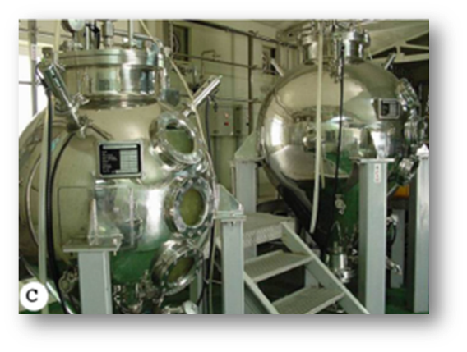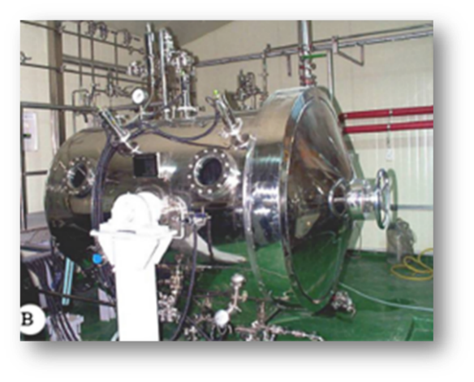
b
a
Plate 11. Different types of bioreactors a. balloon type airlift bioreactors b. drum type airlift bioreactor

Reactor type | Plant species | Reference
Airlift | Panax ginseng | Thanah et al., 2014
Stirred tank | Catharanthus roseus | Drapeau et al., 1986
Bubble column | Nicotiana tabacum | Noguchi et al. (1977)
Fluidized bed | Catharanthus roseus | Morris et al. (1984)
Stirred tank | Nicotiana tabacum | Kato et al. (1977)
Airlift stirred | Morinda citrifolia | Wagner and Vogelmann (1977)

Table 12. Examples of bioreactor types used for plant cell cultures

7. Flow chart of general strategies followed for production of secondary metabolites from plant
Cell and organ cultures

Selection of superior genotype/s

Selection of suitable plant parts or explants

Induction of callus or shoots or adventitious roots or hairy roots

Selection of cell lines or clones

Induction of suspension cultures- flask scale

Medium optimization
(Suitable medium, medium strength, sugar levels, nitrate levels. plant growth regulator levels)

Optimization of culture environments
(Temperature, illumination, light quality, medium pH)

Establishment of small scale bioreactor cultures
(Optimization of inoculum density, agitation, aeration and gaseous)

Screening of biomass and metabolite production

Standardization of elicitation, nutrient feeding, precursor feeding,
permeabilization, immobilization

Establishment of large scale bioreactor cultures

Production of secondary metabolite, Regular/ constant checking of
stability of cell or organ lines. medium parameters, culture environment

Downstream processing

Biosafety tests

Products (Murthy et al., 2014)

8. Limitations of in vitro secondary metabolites production

1. High cost of production.
2. Cultured cells are genetically unstable and may undergo mutation.
3. The production of secondary metabolite may be drastically reduced, as the culture ages.
4. Vigorous stirring is necessary to prevent aggregation of cultured cells, this may often
damage the cells.
5. Strict aseptic condition needed to be followed.

9. Conclusions
The goal of applying in vitro technology in the production of plant pharmaceutical secondary metabolites is to achieve industrial production through the large-scale production system using bioreactors. In vitro culture methods and yield improvement strategies ultimately provide a continuous, reliable source of secondary metabolites and will be the hotspot for the commercial production of pharmaceutical phytochemicals in the coming future.
10. Discussion
1. How we can select high yielding cell lines from heterogeneous cell lines?
Techniques such as visual screening, quantification methods like HPLC (High Performance Liquid Chromatography) and RIA (Radioimmunoassay), growth kinetic analysis methods, inducing mutation (to obtain overproducing cell lines), use of selective (inhibitor/toxic/cytotoxic) agents (for example p-fluorophenylalanine to select high yielding cell lines with respect to phenolics), cell cloning methods (used in case of cell suspension culture) can used to select high-yielding cell lines.
Exposure of plant cells against toxic or any inhibitory stimuli (e.g., environmental stress) and selection of cells that have survived against that stimulus is an another reliable strategy to select high yielding cell lines. Various chemical agents that are used to select high yielding cell lines are 5-methyltryptophan, glyphosate, and biotin.
2. How we can use fungal agent as an elicitors? Is there any chance of contamination in culture by using fungal agents?
Mostly fungal-derived preparations including mycelial extract, cell wall fragments, polysaccharides fractions of cell wall, culture filtrate, yeast cell extract, carbohydrate fractions of yeast extract, etc. are used as elicitors. These preparations are subjected to autoclaving or filter-sterilization before using, so it will not contaminate the culture medium.
3. Is this technology cost effective?
Compare to conventional method, it is a costly method. We have to depend on this technology, if the targeted pharmaceutical phytochemical have high demand and price in the market and its natural source is limited, then only it will be economical. For example taxol, an anticancerous high value drug, which is produced from taxus brevifolis have high demand in market. But it production in nature is very limited. In such a case using of this technology is the alternative method of production.

4. Can you give an example for a company which is using this technique?
Phyton biotech, which is situated in Germany is the largest single supplier of Paclitaxel, anticancerous drug in the world. They have patent for Plant cell fermentation technology.

11. References
Anitha, S. and Ranjitha, B. D. 2006. Stimulation of reserpine biosynthesis in the callus of Rauvolfia tetraphylla L. by precursor feeding. Afr. J. Biotechnol. 5(8): 659-661.
Babu, C. P. 2000. Elicitation of tissue cultures for production of biomedicines, Ph. D. Thesis Kakatiya University, Warangal, A.P., India.
Baranek, K. S., Pietrosiuk, A., Kokoszka, A., and Furmanowa, M. 2009. Enhancement of taxane production in hairy root culture of Taxus x media var. Hicksii. J. Plant Physiol. 166: 1950–1954.
Bhatia, S., Sharma, K., and Dahiya, R. 2015. Classical and nonclassical techniques for secondary metabolite production in plant cell cultures. Academic Press, London. pp.231-291.
Bourgaud, F., Gravot, A., Milesi, S., and Gontier, E. 2001. Production of plant secondary metabolites: a historical perspective. Plant sci. 161(5): 839-851.
Brodelius, P., Deus, B., Mosbach, K., and Zenk, M. H. 1979. Immobilized plant cells for the production and transportation of natural products. Febs. Lett. 103(1): 93-97.
Cardillo, A. B., Alvarez, A. M. O., Lopez, A. C., Lozano, M. E. V., Talou, J. R., and Giulietti, A. M. 2010 Anisodamine production from natural sources: seedlings and hairy root cultures of argentinean and colombian Brugmansia candida plants. Planta. Med. 76:402–405.
Dandin, V. S. and Murthy, H. N. 2012. Enhanced in vitro multiplication of Nothapodytes nimmoniana Graham using semisolid and liquid cultures and estimation of camptothecin in the regenerated plants. Acta. Physiol. Plant. 34:1381–1386.
Drapeau, D., Blanch, H. W., and Wilke, C. R. 1986. Growth kinetics of Dioscorea deltoidea and Catharanthus roseus in batch culture. Biotechnol. Bioeng. 28(10): 1555-1563.
Eilert, U., Constable, F., and Kurz, W. G. W. 1986. Elicitor-stimulation of monoterpene indole alkaloid formation in suspension cultures of Catharanthus roseus, J. Plant Physiol. 126: 11-12.
El-Sayed, M., Choi, Y. H., Frederich, M., Roytrakul, S., and Verpoorte, R. 2004. Alkaloid accumulation in Catharanthus roseus cell suspension cultures fed with stemmadenine. Biotechnol. Lett. 26(10): 793-798.
Felix, H., Brodelius, P., and Mosbach, K. 1981. Enzyme activities of the primary and secondary metabolism of simultaneously permeabilized and immobilized plant cells. Anal. biochem. 116(2): 462-470.
Fukui, H., Yoshikawa, N., and Tabata, M. 1983. Induction of shikonin formation by agar in Lithospermum erythrorhizon cell suspension cultures. Phytochem. 22(11): 2451.
Furuya, T., Yoshikawa, T., and Taira, M. 1984. Biotransformation of codeinone to codeine by immobilized cells of Papaver somniferum. Phytochem. 23(5): 999-1001.
Gangopadhydy, M., Sircar, D., Mitra, A., and Bhattacharya, S. 2008. Hairy root culture of Plumbago indica as a potential source for plumbagin. Biol. Plant 52:533–537.
Jackson, D. E. and Dewick, P. M. 1984. Biosynthesis of podophyllum lignans-I. cinnamic acid precursors of podophyllotoxin in Podophyllum hexandrum. Phytochem. 23(5): 1029-1035.
Jeong, G. T. and Park, D. H. 2006. Enhanced secondary metabolite biosynthesis by elicitation in transformed plant root system: effect of abiotic elicitors. Appl. Biochem. Biotechnol. 129-132: 436-46.
Kato, K., Shiozawa, Y., Yamada, A., Nishida, K., and Noguchi, M. 1972. A jar fermentor culture of Nicotiana tabacum L. cell suspensions. Agric. Biol. Chem. 36(6): 899-902.
Kawauchi, M., Arima, T., Shirota, O., Sekita, S., Nakane, T., Takase, Y., and Kuroyanagi, M. 2010. Production of sesquiterpene-type phytoalexins by hairy roots of Hyoscyamus albus co-treated with copper sulfate and methyl Jasmonate. Chem. Pharm. Bull. 58: 934–938.
Kieran, P. M., MacLoughlin, P. F., and Malone, D. M. 1997. Plant cell suspension cultures: some engineering considerations. J. Biotechnol. 59(1-2): 39-52.
Kim, O. T., Bang, K. H., Shin, Y. S., Lee, M. J., Jung, S. J., Hyun, D. Y., Kim, Y. C., Seong, N. S., Cha, S. W., and Hwang, B. 2007. Enhanced production of asiaticoside from hairy root cultures of Centella asiatica (L.) urban elicited by methyl jasmonate. Plant Cell Rep. 26:1941–1949.
Lee, T. K., Yamakawa, T., Kodama, T., and Shimomura, K. 1998. Effects of chemicals on alkaloid production by transformed roots of Atropa belladona. Phytochem. 49 (8): 2343-2347.
Mathur, A., Gangwar, A., Mathur, A. K., Verma, P., Uniyal, G. C., and Lal, R. K. 2010. Growth kinetics and ginsenosides production in transformed hairy roots of American ginseng—Panax quinquefolium L. Biotechnol. Lett. 32: 457–461.
Moreno, P. R. H., Heijden, R. V. D., and Verpoorte, R. 1993. Effect of terpenoid precursor feeding and elicitation on formation of indole alkaloids in cell suspension cultures of Catharanthus roseus. Plant Cell Rep. 12: 702-705.
Morris, P., Smart, N. J., and Fowler, M. W. 1983. A fluidised bed vessel for the culture of immobilised plant cells and its application for the continuous production of fine cell suspensions. Plant cell tissue organ cult. 2(3): 207-216.
Murthy, H. N., Georgiev, M. I., Kim, Y. S., Jeong, C. S., Kim, S. J., Park, S. Y., and Paek, K. Y., 2014. Ginsenosides: prospective for sustainable biotechnological production. Appl. Microbial. Biotechnol. 98(14): .6243-6254.
Murthy, H. N., Park, S. Y., and Paek, K. Y. 2017. Production of ginsenosides by hairy root cultures of Panax ginseng In Production of Plant Derived Natural Compounds through Hairy Root Culture. Springer. Cham, pp. 203-216.
Mustafa, N. R., Winter, W. D., Iren, F. V., and Verpoorte, R., 2011. Initiation, growth and cryopreservation of plant cell suspension cultures. Nat. protoc. 6(6): p.715.
Nagella, P., Murthy, H. N., 2011. In vitro production of gymnemic acid from cell suspension cultures of Gymnema sylvestre. R. Br. Eng. Life Sci. 11:537–540.
Naik, P. M., Manohar, S. H., Praveen, N., Upadhya, V. and Murthy, H. N. 2012. Evaluation of bacoside A content in different accessions and various organ of Bacopa monnieri (L.) Wettst. J .Herbs Spices Med. Plants 18:387–395.
Naik, P. M., Manohar, S. H., Murthy, H. N. 2011. Effects of macro elements and nitrogen source on biomass accumulation and bacoside A production from adventitious shoot cultures of Bacopa monnieri (L.). Acta. Physiol. Plant 33:1553–1557.
Namdeo, A. G. 2004. Investigation on pilot scale bioreactor with reference to the synthesis of bioactive compounds from cell suspension cultures of Catharanthus roseus Linn. Ph.D. Thesis, Devi Ahiya Vishwavidyalaya, Indore, M.P. India.
Namdeo, A. G., Patil, S., and Fulzele, D. P. 2002. Influence of fungal elicitors on production of ajmalicine by cell cultures of Catharanthus roseus. Biotechnol. Prog. 18: 159-162.
Noguchi, M., Matsumoto, T., Hirata, Y., Yamamoto, K., Katsuyama, A., Kato, A., and Azechi, S. 1977. Improvement of growth rates of plant cell cultures. In Plant Tissue Culture and its Bio-technological application. Springer, Berlin, Heidelberg., pp. 85-94.
Phyton Biotech. 2019. Plant Cell Fermentation (PCF®) Technology [on-line]. Available: https://phytonbiotech.com/apis/docetaxel/ [Accessed 08 Nov. 2019].
Praveen, N., Naik, P. M., Manohar, S. H., Nayeem, A., Murthy, H. N. 2009. In vitro regeneration of brahmi shoots using semisolid and liquid cultures and quantitative analysis of bacoside A. Acta. Physiol. Plant 31:723–728.
Praveen, N., Murthy, H. N. 2010. Establishment of cell suspension cultures of Withania somnifera for the production of withanolide A. Bioresour. Technol. 101:6735–6739.
Putalun, W., Luealon, W., De-Eknamkul, W., Tanaka, H., and Shoyama, Y. 2007. Improvement of artemisinin production by chitosan in hairy root cultures of Artemisia annua L. Biotechnol. Lett. 29: 1143–1146.
Radman, R., Saez, T., Bucke, C., and Keshavarz. T. 2003. Elicitation of plant and microbial systems. Biotechnol. Appl. Biochem. 37: 91-102.
Ramesh, B. T., Amna, T., Ravikanth, G., Gunaga, R. P., Vasudeva, R., Ganeshaiah, K. N., Shaanker, R. U., Khajuria, R. K., Puri. S. C., and Qazi, G. N. 2008. Prospecting for camptothecines from Nothapodytes nimmoniana in the western ghats, south india: identification of high-yielding sources of camptothecin and new families of camptothecines. J. Chromatogr. Sci. 46:362–368.
Rao, S. R. and Ravishankar, G. A. 2002. Plant cell cultures: chemical factories of secondary metabolites. Biotechnol. Adv. 20(2): 101-153.
Ravishankar, G. A. and Rao, S. R. 2000. Biotechnological production of phyto-pharmaceuticals. J. Biochem. Mol. Biol. Biophys. 4: 73-102.
Rokem, J. S., Schwarzberg, J., and Goldberg, I. 1984. Autoclaved fungal mycelia increase production in cell suspension cultures of Dioscorea deltoida. Plant Cell Rep. 3: 159-160.
Rostampour, S., Sohi, H. H., Jourabchi, E., and Ansari, E. 2009. Influence of Agrobacterium rhizogenes on induction of hairy roots and benzylisoquinoline alkaloids production in Persian poppy (Papaver bracteatum Lindl.): preliminary report. World J. Microbiol. Biotechnol. 25: 1807–1814.
Sangwan, R. S., Chaurasiya, N. D., Lal, P., Misra, L., Uniyal, G. C., Tuli, R. and Sangwan, N. S., 2007. Withanolide A biogeneration in in vitro shoot cultures of Ashwagandha (Withania somnifera D UNAL), a Main Medicinal Plant in Ayurveda. Chem. Pharma. Bull. 55(9): 1371-1375.
Shilpha, J., Satish, L., Kavikkuil, M., Largia, M. J. V., and Ramesh, M. 2015. Methyl jasmonate elicits the solasodine production and anti-oxidant activity in hairy root cultures of Solanum trilobatum L. Ind. Crops Prod. 71: 54-64.
Sim, S. J., Chang, H. N., Liu, J. R., and Jung, K. H. 1994. Production and secretion of indole alkaloids in hairy root cultures of Catharanthus roseus: effects of in situ adsorption, fungal elicitation and permeabilization. J. ferment. bioeng. 78(3): 229-234.
Simola,L. K., Parviainen, R., Martinsen, A., Huhtikangas, A., Jokelat, R., and Lounasmaa, M. 1990. Feeding experiments using suspension cultures of Atropa belladonna; limiting steps in the biosynthesis of tropane alkaloids. Phytochem. 29(11): 3517-3523.
Sirikantaramas, S., Sudo, H., Asano, T., Yamazaki, M., and Saito, K. 2007. Transport of camptothecin in hairy roots of Ophiorrhiza pumila. Phytochem. 68:2881–2886.
Srinivasan, V., Ciddi, V., Bringi, V., and M. L., and Shuler, M. L. 1996. Metabolic inhibitors, elicitors and precursors as tools for probing yield limitation in taxane production by Taxus chiensis cell cultures. Biotechnol. Prog. 12(4) : 457-465.
Thanh, N. T., Murthy, H. N., and Paek, K. Y. 2014. Optimization of ginseng cell culture in airlift bioreactors and developing the large-scale production system. Ind. Crops Prod. 60: 343-348.
Wagner, F. and Vogelmann, H. 1977. Cultivation of plant tissue cultures in bioreactors and formation of secondary metabolites. In Plant Tissue Culture and Its Bio-technological Application. Springer, Berlin, Heidelberg, pp. 245-252.
Wang, C., Wu, J., and Mei, X. 2001. Enhanced taxol production and release in Taxus chinensis cell suspension cultures with selected organic solvents and sucrose feeding. Biotechnol. progress, 17(1): 89-94.
Wichers, H. J., Malingre, T. M., and Huizing, H. J. 1983. The effect of some environmental factors on the production of L-DOPA by alginate-entrapped cells of Mucuna pruriens. Planta, 158(6): 482-486.
Wu, J. and Lin, L. 2003. Enhancement of taxol production and release in Taxus chinensis cell cultures by ultrasound, methyl jasmonate and in situ solvent extraction. Appl. Microbiol. Biotechnol. 62(2-3): 151-155.
Yue, W., Ming, Q. L., Lin, B., Rahman, K., Zheng, C. J., Han, T. and Qin, L. P. 2016. Medicinal plant cell suspension cultures: pharmaceutical applications and high-yielding strategies for the desired secondary metabolites. Crit. rev. biotechnol. 36(2): 215-232.

KERALA AGRICULTURAL UNIVERSITY
COLLEGE OF HORTICULTURE, VELLANIKKARA
Department of Plantation Crops and Spices
PSMA 591: Master’s Seminar
Name : Abhaya M. C. Venue : Seminar hall Admission No. : 2018-12-004 Date : 21-11-2019
Major advisor : Dr. B. Suma Time : 11.30 am

In vitro plants secondary metabolites production: A hotspot for pharmaceutical phytochemicals
Abstract
Pharmaceutical phytochemicals are biologically active compounds produced by the plants, which are used for medicinal drug preparations. Plant kingdom synthesizes enormous form of complex structured phytochemicals, known as secondary metabolites, to interact with biotic environment and for the establishment of defence mechanisms. Conventionally, such pharmaceutical phytochemicals are isolated either from the cultivated plants or from the wild plants. However, these sources alone cannot meet the rising demand of phytochemicals for drug preparation. Chemical synthesis of these high-value medicinal compounds is also not economical, due to their complex structures.
To overcome such problems, the cell and organ culture is emerging as an attractive alternate method. The principle of this biotechnological tool is the biosynthetically totipotent nature of culturing cells. Cell preserves the genetic information and thus it is capable of producing large number of biochemicals which are found in the parent plant, under a suitable nutrient culture medium.
Cell suspension culture and organ cultures from adventitious root, adventitious shoot and Agrobacterium rhizogenes mediated hairy root are the leading approaches used in the production of high value pharmaceutical phytochemicals. Ginsenosides, a group of saponins, well known for their antioxidant activity could be produced successfully from cell suspension culture of Panax ginseng C. A. Meyer (Thanh et al., 2014) and solasodine, a steroid alkaloid, could be produced from hairy root culture of Solanum trilobatum L. (Shilpha et al., 2015).
Various systematic strategies like selection of cell lines and clones, optimization of medium and culture environments, elicitor treatment, precursor feeding, permeabilization, immobilization and scale-up using bioreactors can boost the commercial success of culture system. Elicitors are substances which, when introduced in a small concentration, can initiate the plant cell defence mechanism and secondary metabolite synthesis in cultured cells. Methyl jasmonate when used as an elicitor, it increased taxol yield in the Taxus chinensis cell suspension culture (Wu and Lin, 2003). The exogenous supply of precursor, a compound which is an intermediate involved in the biosynthetic pathway, will trigger the secondary metabolite production by utilizing the pre-existing enzyme system. For instance, tryptophan in the callus induction medium of Rauvolfia tetraphylla L. enhanced the yield of an alkaloid, reserpine (Anitha and Ranjitha, 2006).
Cell suspension culture has been employed by Phyton Biotech (Germany), which is the largest single supplier of Paclitaxel in the world, a well-known anticancerous drug (Phyton Biotech, 2019).
Different culture methods, yield improvement strategies and large-scale production system using bioreactors ultimately open up a continuous and reliable source of secondary metabolites. Hence, they will be the hotspot for the commercial production of pharmaceutical phytochemicals in the coming future.
References
Anitha, S. and Ranjitha, B. D. 2006. Stimulation of reserpine biosynthesis in the callus of Rauvolfia tetraphylla L. by precursor feeding. Afr. J. Biotechnol. 5(8): 659-661.
Phyton Biotech. 2019. Plant Cell Fermentation (PCF®) Technology [on-line]. Available: https://phytonbiotech.com/apis/docetaxel/ [Accessed 08 Nov. 2019].
Shilpha, J., Satish, L., Kavikkuil, M., Largia, M. J. V., and Ramesh, M. 2015. Methyl jasmonate elicits the solasodine production and anti-oxidant activity in hairy root cultures of Solanum trilobatum L. Ind. Crops Prod. 71: 54-64.
Thanh, N. T., Murthy, H. N., and Paek, K. Y. 2014. Optimization of ginseng cell culture in airlift bioreactors and developing the large-scale production system. Ind. Crops Prod. 60: 343-348.
Wu, J. and Lin, L. 2003. Enhancement of taxol production and release in Taxus chinensis cell cultures by ultrasound, methyl jasmonate and in situ solvent extraction. Appl. Microbiol. Biotechnol. 62(2-3): 151-155.

